
SUPERIOR UNIVERSITY GOLD
CAMPUS

- Name: Muhammad Abdullah
- Department: BS Artificial Intelligence
- Section: BSAI-3A
- Subject: AI (Lab)
- Submitted to: Sir Rasikh
- Roll no: SU92-BSAIM-F25-022

Lab Task 5
(Question 2)

- Minimax Code Output :
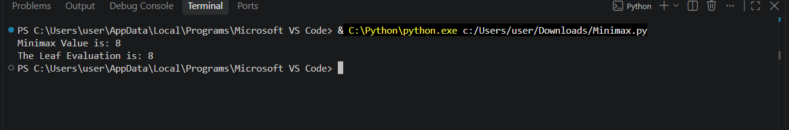

- Alpha-Beta Pruning Output:
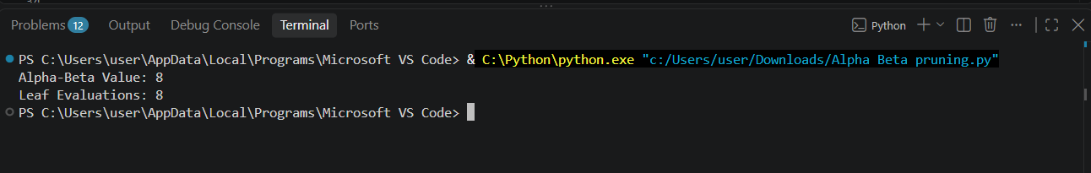

Final Comparison:
Measurement | Minimax | Alpha Beta Pruning
Optimal value | 8 | 8
Leaf evaluations | 8 | 6
Pruned leaves | 0 | 2

In Minimax we calculate the all 8 leaf nodes to calculate the optimal result while in Alpha Beta Pruning case we skip the unnecessary branches.For this case we check only 6 nodes and pruned the 2 nodes and get the same optimal result.

“ Documentation ”

First issue I face in code writing is counting number of leaf nodes in both algorithms so I added a leaf node counter in which the value is incressed when the node is reached.I use alpha>=beta condition that stop visit the branches that does not effect the final result.Another problem in understanding is how recursive call between Max or Min nodes for this parameter “maximizing” is use to alternate between the Max and Min at each node.Solving and understanding the problem I learned how By solving these problems, I learned how Minimax evaluates the tree and Alpha-Beta Pruning reduces unnecessary leaf evaluations.

